# MINUTES

## Date

4/06/2024

## Type of Meeting

Monthly meeting

## Attendees

Phoebe Cooney

Sebastian Baszczyj

Brody Frost

Ryan Saunders

Luke Pearson

## Actions from last Meeting

* Double up of roles
* Ask for help if struggling
* Encourage members to come to class - attendance

## New Actions/Issues moving forward

* Put notes, usernames/passwords and all of our documentation into our own respective branches on GitHub.
* Do the configuration of Vlan
* Install elastic defend on DMZ
* Checking tasks on ms projects (gantt chart)
* Determining the percentage of work done on ms projects (gantt chart)
* Determining variation
* Determining risk chart
* Determining costs for the project
* Determining baseline
* Doing monthly project report
* Doing critical task analysis

## Trello Screen shots

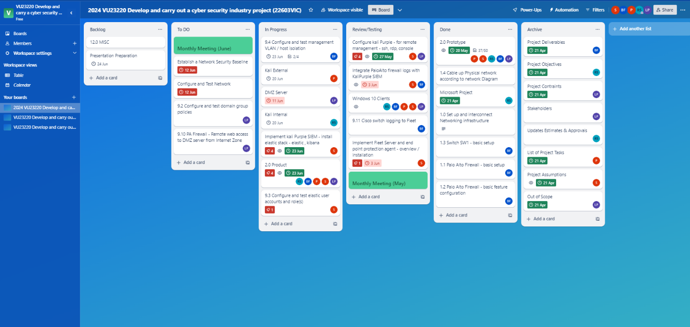

## GitHub Screen Shots.

